Template And Author Guidelines For
IWMS24 Paper Submission

E. Hansen¹, S. Leavengood¹, D.C.Wong²

1 College of Forestry, Oregon State University, Corvallis, OR, USA
2 FPInnovations, 2665 East Mall, Vancouver BC, CANADA

ABSTRACT
Please use this document as a template for print-ready submission of your paper for inclusion in the IWMS-24 proceedings. It provides detailed formatting instructions to achieve a uniform professional appearance among all papers. Please strictly follow the set format without modification, even though you may have different personal preferences. The proceedings will be printed on letter size (11” x 8.5”, 216 mm x 279 mm) paper, so please be careful to retain this setting should your customary size be different. Please submit your original Word document and a duplicate version in PDF format. The abstract should not exceed 300 words.
Keywords: Author guidelines, proceedings, IWMS 24, …, max. 5.

Introduction
The total length of an IWMS-24 paper (including figures, references, acknowledgements etc.) is typically between 7 to 10 pages (same for both oral and poster presentations). The paper must be written in English, including all text contained in the tables and figures. The standard font type is Times New Roman for all titles, text, captions of figures and tables. The font sizes are established in this template, please do not change them. Also note that all figures will be printed in black and white, so be sure that they are readable in greyscale and do not depend on color interpretation.

materials and methods (this section name can be varied according to need)

Secondary heading (if needed)
Refer to tables and figures in the text using the whole word. Examples: Table 1 shows the log characteristics. Figure 1 illustrates the log sawing pattern.
Place the title of a table centered above the table and the title of a figure centered below the figure. Use bold font for the initial word and number in these titles. For example:

Table 1. Log characteristics.

Site | Diameter (mm) | Taper (mm/m)
Lima | 205 | 19
Pisco | 173 | 9

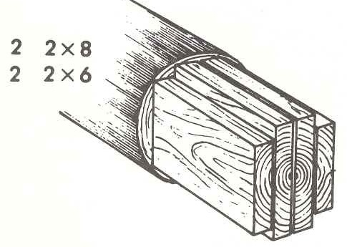
Figure 1. Log sawing pattern.

Results and discussion (this section name can be varied according to need)

Secondary heading (if needed)

conclusions
Conclusions should briefly summarize the main results of the work and draw attention to the key findings. They can also include perspectives for further work needed and for potential new developments.

Acknowledgements
Enter acknowledgements directly before the references.

References
The bibliography should follow the format illustrated below. The examples are: (1) a book reference, (2) a journal article, (3) an article in a conference proceeding, (4) a chapter in a book, (5) a web reference. Note: use web page citations very sparingly, if at all, because they can change rapidly and links frequently become unreachable.
The references should be numbered in the order in which they appear in the text. Place references in the text using number(s) within [square brackets]. If needed, use commas and ranges, e.g., [1–3, 5].

- Tikhonov A, Goncharsky A, Stepanov V, Yagola A (1995) Numerical Methods for the Solution of Ill-Posed Problems. Kluwer, Dordrecht.
- McLauchlan TA, Norton JA, Kusec DJ (1973) Slope of Grain Indicator. Forest Products Journal 23(5):50-55.
- Leicester RH, Seath CA (1996) Application of Microwave Scanners for Stress Grading. 4th International Wood Engineering Conference, New Orleans. 2:435-440.
- Parulski K, Spaulding K (2002) Color Image Processing for Digital Cameras. In: Sharma G (ed) Digital Color Imaging Handbook. CRC Press,
- Canadian Wood Council (2016) Grades. [online]. Available at: http://cwc.ca/wood-products/lumber/visually-graded/grades/ [Accessed 11 Dec. 2016].

